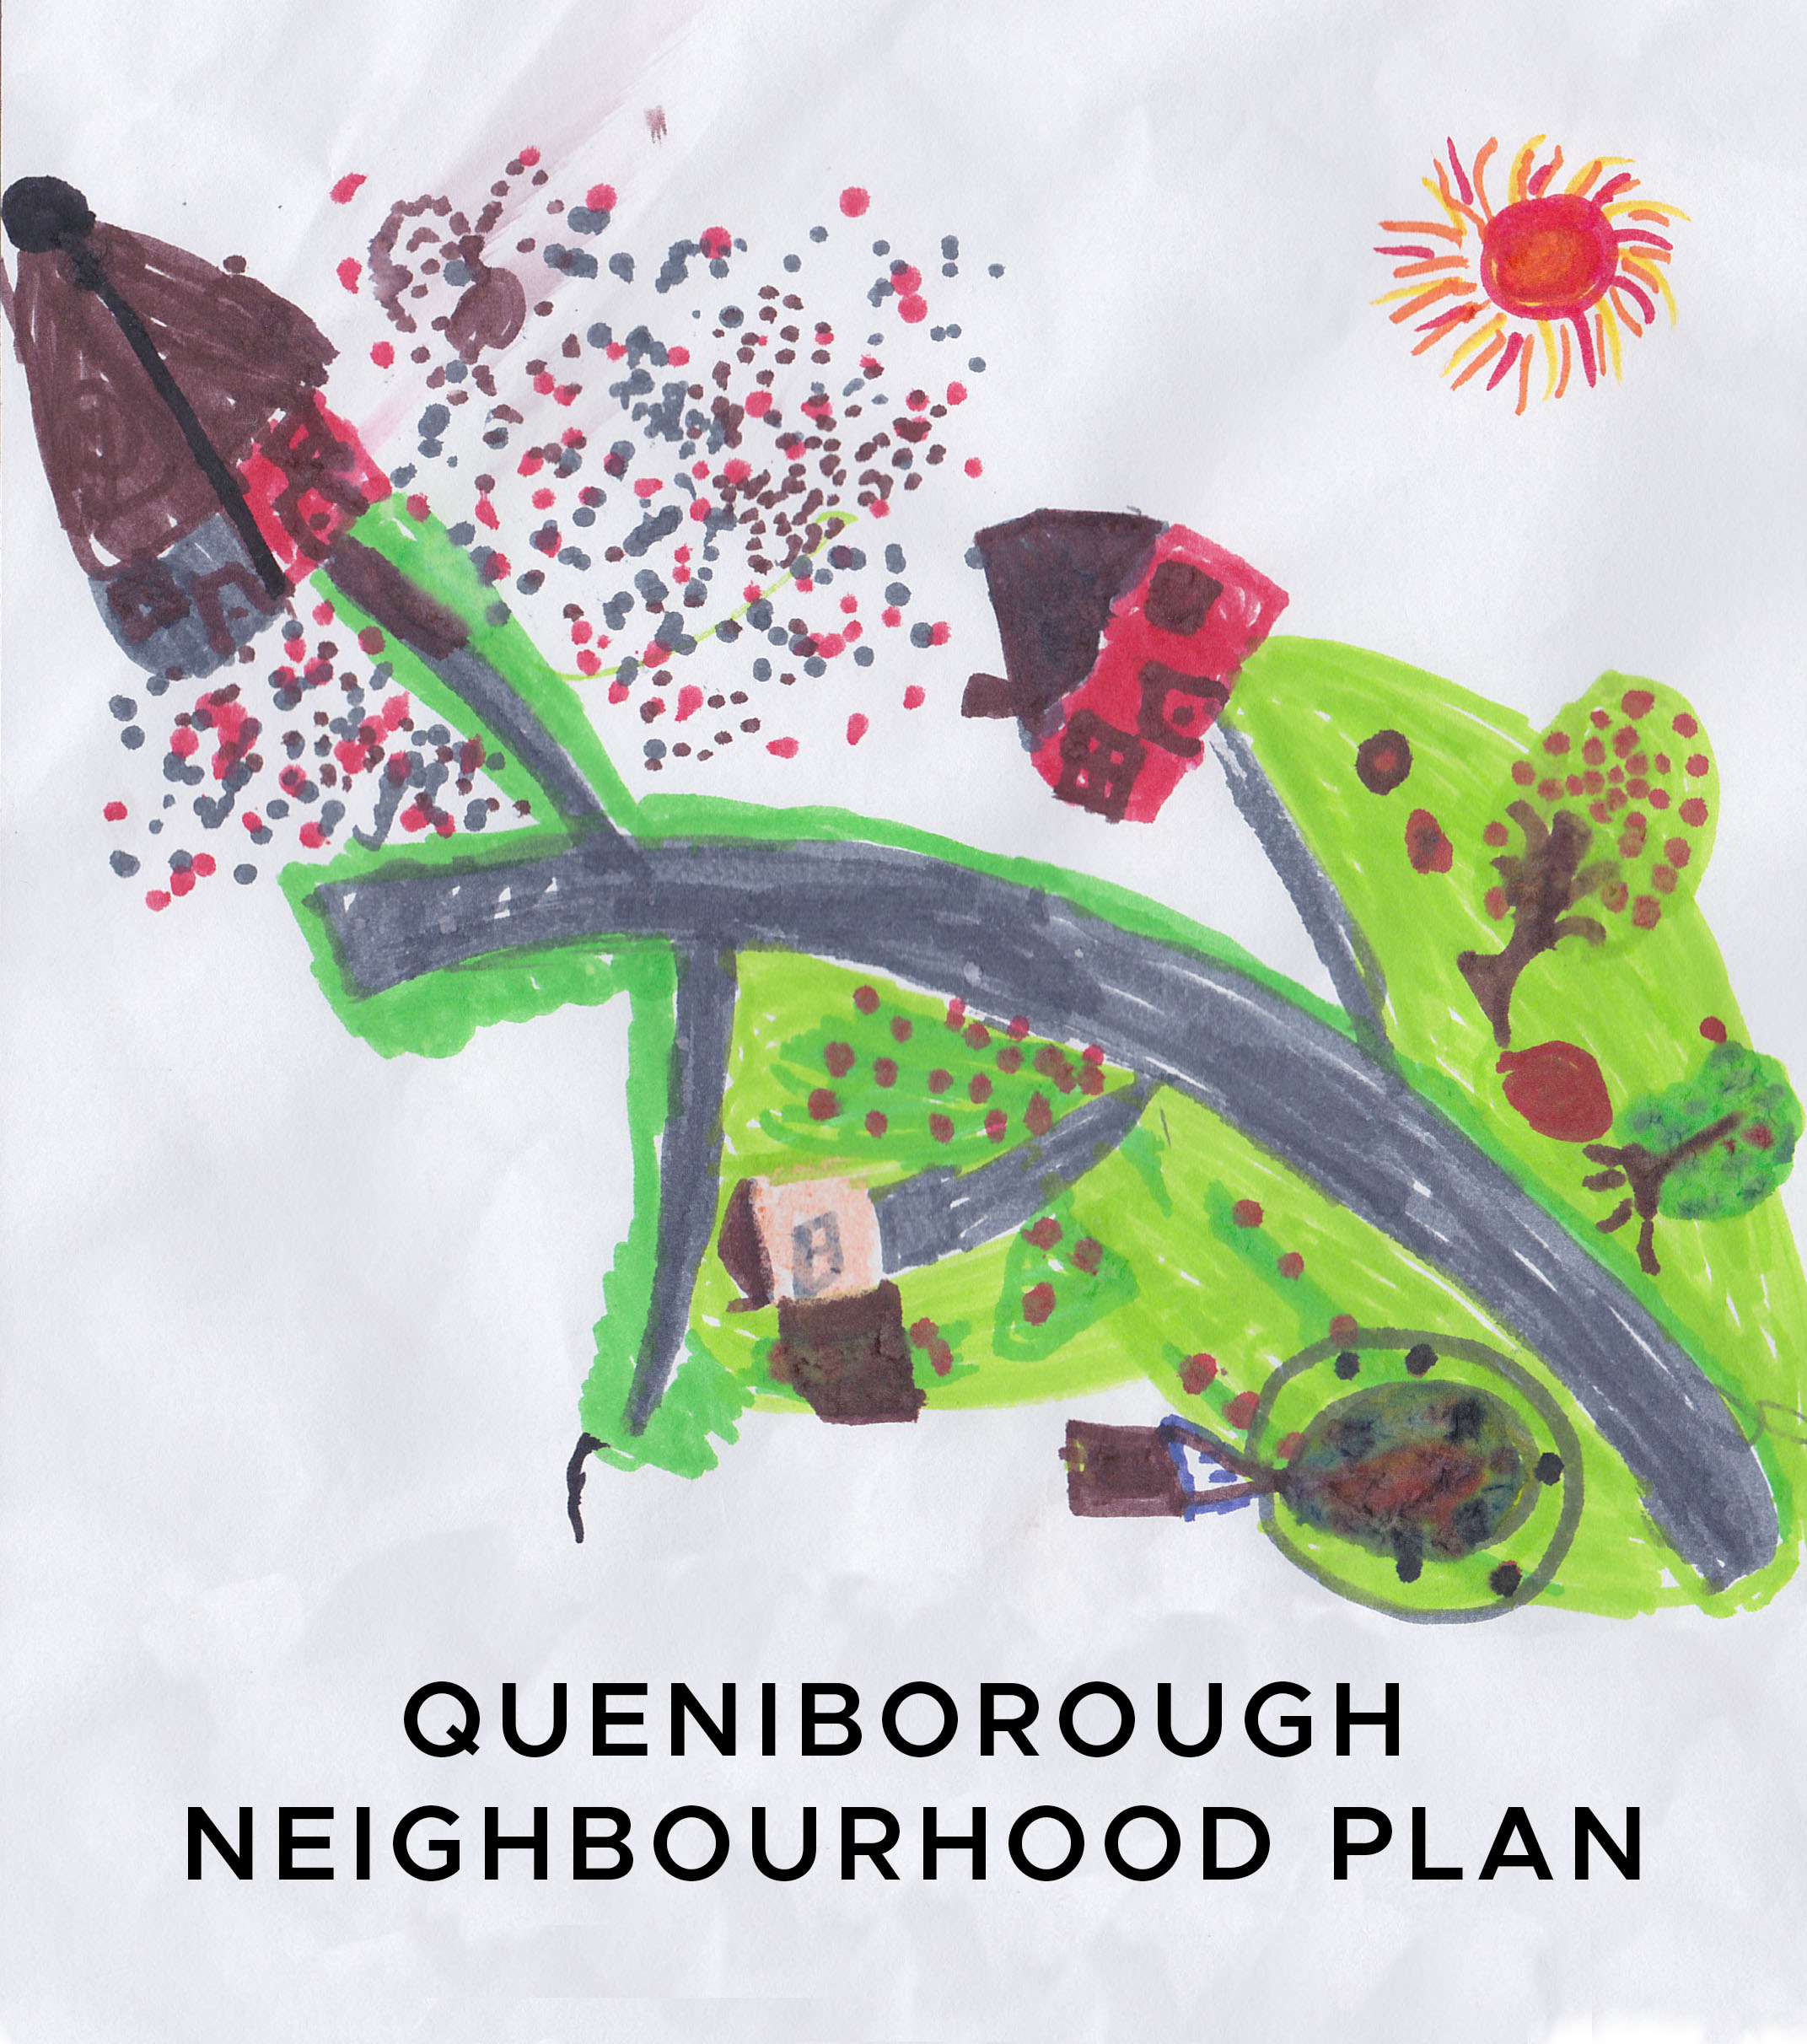

**Minutes of the meeting of the Neighbourhood Plan Steering Group**

**held at 7.30pm in the Council Meeting Room**

**on Tuesday, 9th July, 2019**

**Present:** Pam Jones, Mick Wiseman, Liz Ellis, Mike Duxbury, Phil Laughton, Susan Graham, Neill Ransom, Ben King, John Weston and Kate Hill

**Apologies:** Paresh Patel and Carole Shaw

**1. Declaration of interest and request for dispensation**

None registered.

**2.** **Minutes of meeting held on 11th June, 2019**

Agreed as proper record of meeting. Proposed by LE and seconded by MD.

**3.** **Matters arising from those Minutes**

It was noted that Hallams had withdrawn their appeal against CBC’s refusal to allow 220 dwellings to be built on Melton Road.

**4. Local Green Spaces – completed pro-formas**

It was decided that the Brook Field should be listed as a LGS and JW will complete the pro-forma for it. PL will contact the person responsible for bio-diversity at CBC, who has offered to send us information about important wildlife sites, which includes the Brook Field. Ten LGS sites have been identified to date and it was decided that all pro-formas should be completed and sent to PJ by 30th July for onward transmission to CW.

**5. Q.27 – update**

A discussion took place about the proposed new extended conservation area and many of the structures listed by residents under Q27 fall within this area. KH will update the information to be forwarded to CW by 30th July. **AP - KH**

**6.** **Review of grids**

It was decided that the best way to review the grids and identify all non-planning issues to be incorporated into the Community Action Plan was for the original working groups to reconvene at a later date to suit all parties and submit their final reviews to PJ before 30th July, although LE and KH will not be able to work on the traffic and transport grid until 7th August. **AP – All**

**7. Agenda items for next meeting on 13th August, 2019**

Standard items plus funding and review of pre-submission draft.