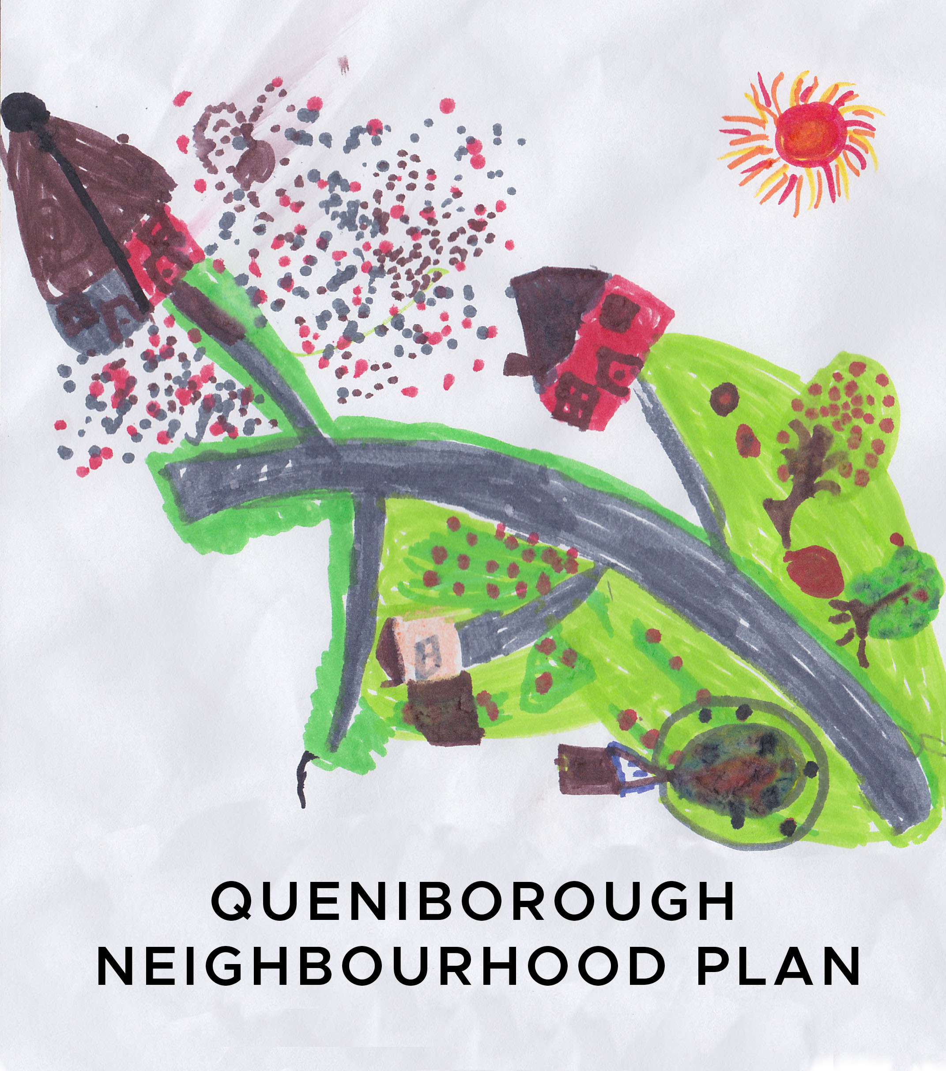

**Minutes of the meeting of the Neighbourhood Plan Steering Group**

**held at 7.30pm in the Council Meeting Room**

**on Tuesday, 11th June, 2019**

**Present:** Pam Jones, Mick Wiseman, Liz Ellis, Mike Duxbury, Paresh Patel, Kate Hill,

Jhanvi Shukla and Colin Wilkinson

**Apologies:** Neill Ransom, Phil Laughton, John Weston, Susan Graham, Ben King and

Carole Shaw

**1. Declaration of interest and request for dispensation**

None registered.

**2.** **Minutes of meeting held on 14th May, 2019**

Agreed as proper record of meeting. Proposed by LE and seconded by MD.

**3.** **Matters arising from those Minutes**

PJ will draft an article for the next Gazette after our next meeting in time for the deadline of 12th July. **AP: PJ**

**4. Planning applications - update**

KH had received a letter from CBC advising that an inspector had been instructed by the Secretary of State to hear Gladman’s appeal against Charnwood’s refusal to grant planning permission for 270 houses at East Goscote. The inquiry into the appeal will commence on Tuesday, 18th June at 10am at The Ramada Hotel, 22 High Street, Loughborough, LE11 2QL and is scheduled to last for 6 days. CW advised that anyone can attend the appeal and if anyone wishes to speak they should inform the inspector upon arrival.

**5. LCC NP networking event**

PJ, LE and PL attended the event. John Wilkinson from Locality talked about monitoring NPs once they have been adopted to make sure that any planning applications met with the stipulations in the plan. There was also a talk about CLH (community led housing). JS will forward the slides from the meeting to steering group members. The next meeting will be in November – date to be confirmed.

**AP: JS**

**6.** **Local green spaces – update**

CW advised that we may need to include other areas not originally identified in the questionnaire but specified by respondents, although some may not meet the criteria needed to be recognised as a LGS. He also advised that private ownership does not preclude an area from designation. Criteria includes: heritage/beauty/diversity/

recreation, although this list is not exhaustive and landowners and developers do challenge the criteria. He recommended that the steering group complete the pro-formas as much as possible then bring them to a future meeting for discussion. OS maps available to the PC will give the measurements of each area.

**7. Settlement boundaries**

CW advised that there are three development boundaries in Queniborough. The latest is from the local plan approved in 2004 (shown in blue on the map) and this includes the Old Hall but not the Millstones or Barkby Road developments as they came later. The boundary shown in red on the map relates to a new statute to limits of development instigated by CBC last year but this does not have much status as it has just been sent out for consultation. In some areas these lines cut across parts of some large gardens, which has probably been done in order to prevent infill housing. The purple boundary line shown on the map is the one shown in the questionnaire. CW said he is comfortable with the Old Hall being outside the boundary as we must show consistency and would therefore have to consider any other buildings outside the boundary. Everyone will have a chance to have their say once the draft plan is produced as CBC will have a six week consultation period. We should consider any representations and respond accordingly. After that the draft plan goes to CBC and we have no further say. We can justify any decisions we have made.

**8. Review of revised draft NP**

The results of the questionnaire have now been incorporated into the plan, as has the data from the vehicle activated sign, along with wildlife corridors. A paragraph about any possible future development of the Queniborough Lodge site has also been added as a policy and it was agreed that bungalows should be added to that policy as this will make it easier for older people to get into Syston for shopping/doctors etc. As there is no available land for allotments PJ suggested the PC should encourage residents with large gardens who are no longer able to care for them to allow those who would like an allotment the use of their gardens, which would be mutually beneficial. This item will be added to the plan under the Community Action Plan.

A discussion followed about Q.27 of the questionnaire regarding other structures that had been cited by residents as being of notable importance. The dovecote is already locally listed but the old school is not. CW suggested it should therefore be included. We should take a photograph of it and give a brief description and state why it is important. This should also be done for any other buildings/structures which have been highlighted under Q27. MW will take photographs and mark their position on the map and KH will provide a description and justification for their inclusion. It was decided that the trees and spring bulb display at the crossroads should be added as another local green space and PJ will complete the relevant pro-forma.

CW suggested we should be ready to submit the plan for consultation following our September meeting, in which case we will need to tie up any loose ends at our July meeting by reviewing the grids we completed previously, make sure we have completed the pro-formas for the green spaces and complete the work required on Q.27 detailed above. The PC will need to approve the draft plan but CBC do not – they will be a consultee. **AP: PJ, MW, KH**

**9. Agenda items for next meeting on 9th July, 2019**

Standard items plus pro-formas for local green spaces, review of grids, additional structures to be covered under Q.27.