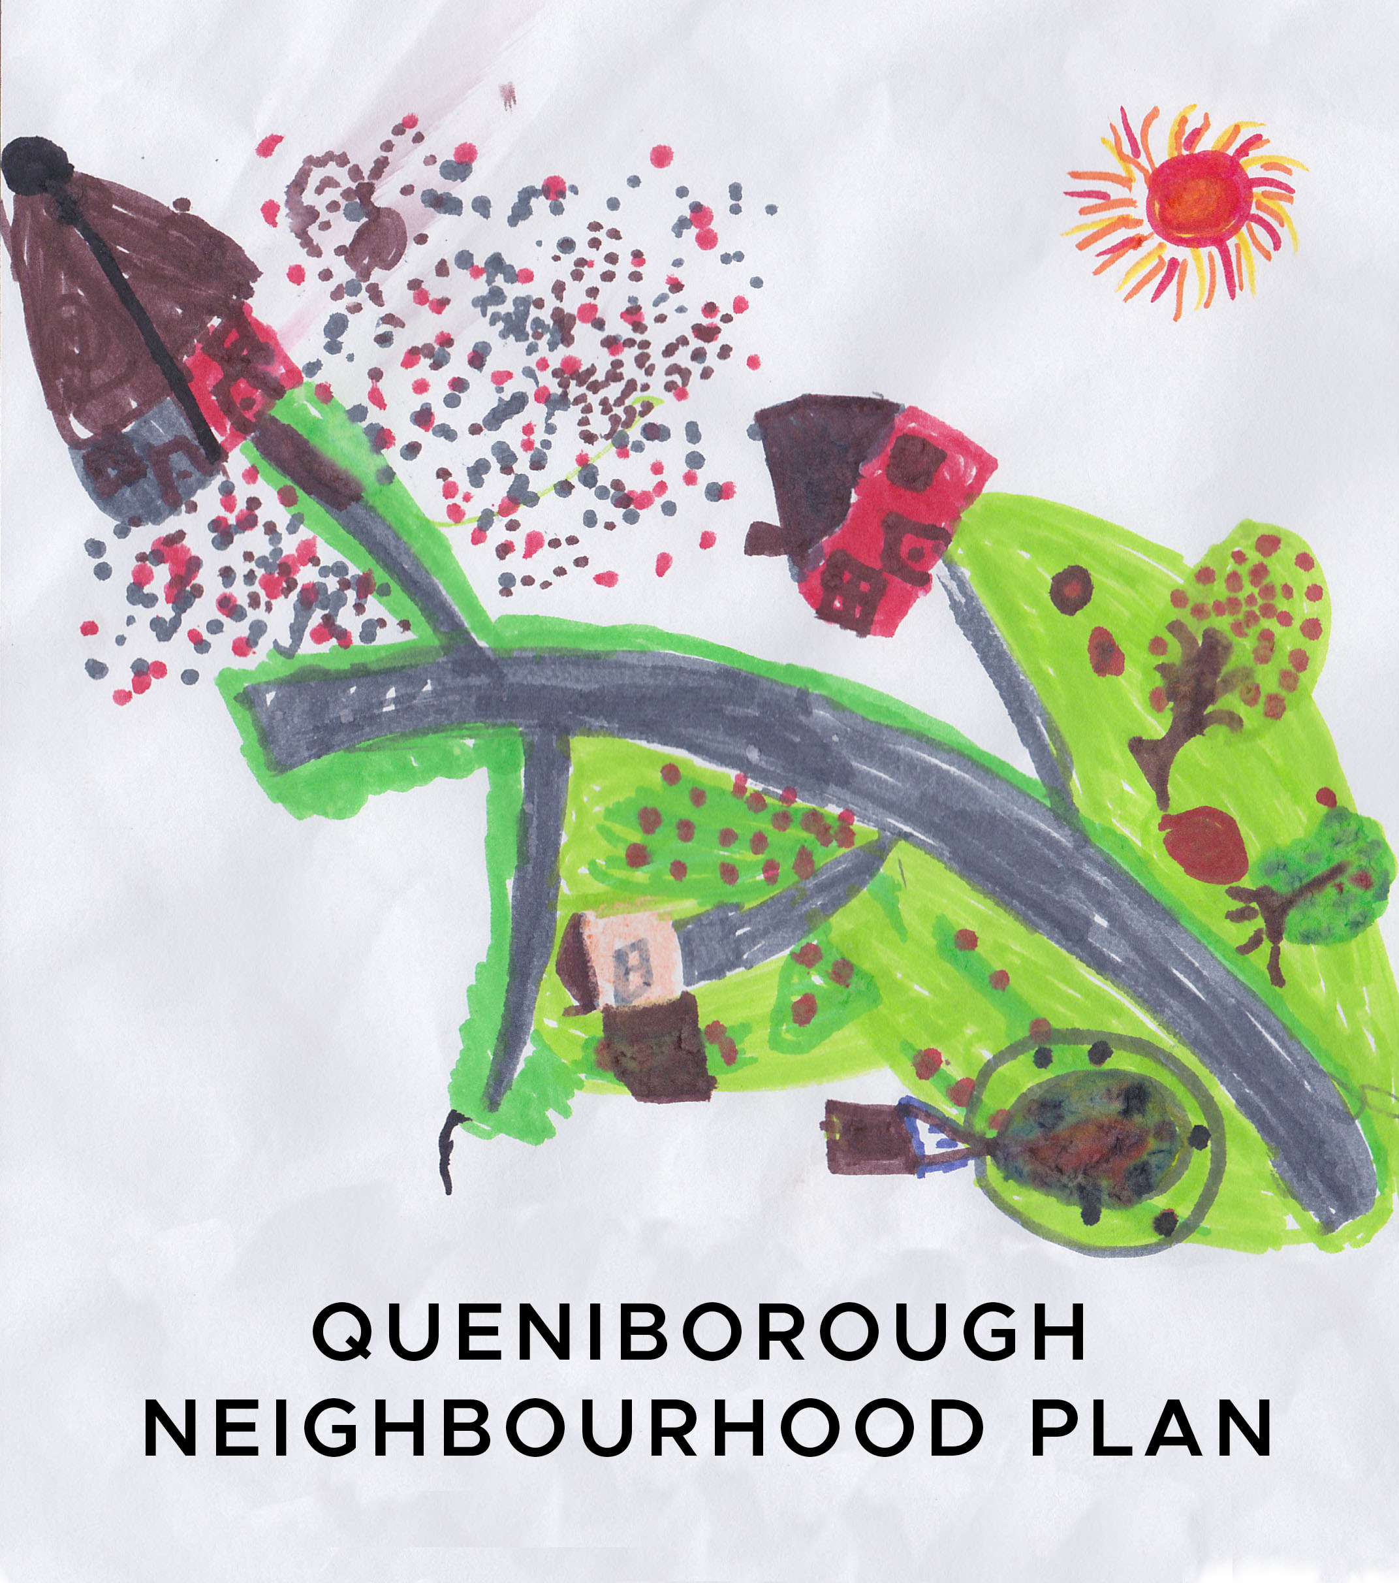

**Minutes of the meeting of the Neighbourhood Plan Steering Group**

**held at 7.30pm in the Council Meeting Room**

**on Tuesday, 12th March, 2019**

**Present:** Pam Jones, Phil Laughton, Mick Wiseman, Liz Ellis, Mike Duxbury, Ben King,

Susan Graham, John Weston, Kate Hill and Jhanvi Shukla

**Apologies:** Neill Ransom, Paresh Patel and Carole Shaw

**1. Declaration of interest and request for dispensation**

None registered.

**2.** **Minutes of meeting held on 12th February, 2019**

Agreed as proper record of meeting. Proposed by LE and seconded by MD.

**3.** **Matters arising from those Minutes**

PJ advised she had sent letter to CBC confirming the steering group’s agreement to the proposed extension of the conservation area boundary and had also sent a letter to the Rearsby steering group in support of their neighbourhood plan. She also confirmed that the date on the Rearsby plan had now been amended to run from 2018-2028 instead of 2018-2036. PL advised that Joy Hardy had presented her petition to the Environment and Traffic Overview and Scrutiny Committee at it is available to view on YouTube. Officers from the traffic section will look at it and report back to their next meeting in June. James Poland expected some sort of referral back to the village for consensus. PL will send out the link. Following receipt of an email from Nik Green (LCC networking event coordinator) querying NP funding JS advised that some funding for NPs had been rejected by Awards For All. Technically they are not saying no but want to concentrate on community support work, with Locality and Parish Councils providing funds for NPs but this decision will not affect us. It was noted that Hallam Land Management had lodged an appeal against the refusal to allow outline planning permission for 220 houses on Melton Road. **AP - PL**

**4. LCC – NP Networking Event**

PJ advised that the next meeting will be held on 21st May from 5.30-8.00pm. The agenda is 1) Community-led housing; 2) Local planning in support of NPs; 3) Made plan reviews and monitoring. PJ, PL and LE plan to attend. PL advised that the government is making £8,000,000 available to PCs to act on behalf of their communities specifically with regard to community housing.

**5. Questionnaire – finalise distribution and data inputting details**

PJ thanked JS and JP on behalf of the steering group for their hard work in producing thequestionnaires. The cost of production was £470 for 1,500 copies and the combined cost of the A4 envelopes, labels and photocopying came to £45.79, which means we have £134.21 still in the fund. JS will ask the printers for an invoice prior to the next PC meeting. Thanks to Callie for highlighting the importance of completing the questionnaire by including a Stop Press on the front cover of the Gazette regarding Hallam’s appeal to build the 220 houses on Melton Road. PL will forward to steering group members percentage response figures from various villages in the area that have completed their NP questionnaires. MW advised he had offered to collect questionnaires from residents in Primrose Way. It was agreed that any completed paper copies handed in to S&J News, PJ or the PC would be initialled and numbered eg: SJ1, PJ1, PC1 etc and the person inputting the data online would enter that number followed by their initials in the “Anything Else” box at the end of the questionnaire, so in case of any errors it would be possible to trace it back. PJ will email everyone when they need collecting so we can start inputting the data. JS will advise tomorrow how long they will need to produce their report. It was agreed that in order to give RCC time to do this the April meeting would be cancelled. PL will produce posters to be displayed around the village to serve as reminders to residents. JS will amend the youth questionnaire to give the option “M/F/Prefer not to say” and confirmed there is a 9,999 character restriction for each box in the questionnaires so as not to restrict what people may want to say. RCC will share the results with CW and advise him of our next meeting date on 14th May so he can be present and expect that he will attend future meetings. JS mentioned the RCC Village Awards Scheme and suggested nominating the Gazette for an award. However, PL advised that it had previously been nominated but nothing was heard from RCC. He will forward the previous nominations to JS for information. **AP – JS, PL**

**6. Agenda items for next meeting on 14th May, 2019**

Standard items plus RCC’s report on questionnaire.