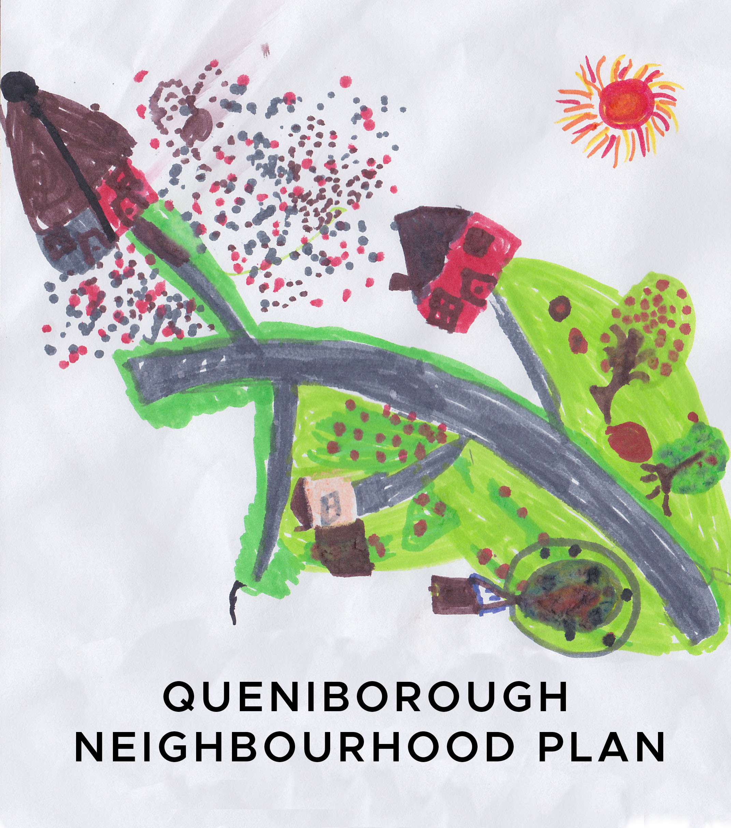

**Minutes of the meeting of the Neighbourhood Plan Steering Group**

**held at 7.30pm in the Council Meeting Room**

**on Tuesday, 8th January 2019**

**Present:** Pam Jones, Paresh Patel, John Weston, Phil Laughton, Mick Wiseman,

Liz Ellis, Mike Duxbury, Ben King, Susan Graham and Jhanvi Shukla

**Apologies:** Mike Jones, Neill Ransom, Kate Hill and Carole Shaw

**1. Declaration of interest and request for dispensation**

None registered.

**2.** **Minutes of meeting held on 11th December 2018**

Agreed as proper record of meeting. Proposed by PL and seconded by JW.

**3.** **Matters arising from those Minutes**

Thanks given to MW for updating, collating and uploading photographs, for inclusion into the draft NP, onto Dropbox.

The start date for the funding from ‘Awards for All’ was confirmed by PL as 1st June 2018 which runs for one year from this date. JS to ask JP to invoice PL, as Parish Clerk, for work completed to date and also to confirm when we need to apply for the remainder of the Locality Grant. **AP: JS, JP**

**4. Draft Questionnaire**

PJ identified that the next Gazette copy date is 11th January and she’ll produce an article and circulate a copy to the group for comment. **AP: PJ**

The next copy date is 1st March and the Gazette is to be issued on 15th March. The group agreed to target these dates for the completion, promotion and delivery of questionnaire. MW offered to ask Callie if we can insert the questionnaire into the Gazette. Volunteers will then be needed to complete this before the 15th March. Need to ask Callie if we can have the front page to promote the questionnaire.

**AP: MW, PJ**

JS will organise the printing of the questionnaire and obtain a quote. **AP: JS**

The group agreed that the deadline for completion of the questionnaire will be 31st March. This gives the group a week to collate all the results before the April meeting. It was agreed that the Queniborough Parish Council (QPC) office will be a drop-off point for the completed questionnaire and for villagers to obtain extra paper copies. PJ will ask if S&J News will agree to be an alternative location. **AP: PJ**

JS presented the draft questionnaire to the group and was thanked for all her hard work. The group went through the questionnaire making any necessary amendments and were asked if they notice any additional changes to send them to PJ who’ll forward them to JS. **AP: All**

Regarding Q32, the green spaces that the villagers identified on the map, at the Community Consultation event, will be included. PJ to forward the list to JS.

**AP: PJ**

It was also agreed that no prize will be awarded. JS offered to produce an on-line questionnaire, targeted at 11–18 year olds. A paper version will also be available at the QPC Office and S&J News. **AP: JS**

An on-line version of the main questionnaire, along with the children’s questionnaire, will be placed on SNAP, hosted by RCC. This will give an alternative way for villagers to complete the questionnaire. SNAP is also able to collate all the results.

All questionnaires will be promoted on Facebook, Queni Online and hopefully the front page of the Gazette.

**5. Draft NP - Update**

PJ forwarded CW information regarding the School Logo Competition and School Questionnaire to be included into the draft NP. Comments, additions or amendments still to be sent to PJ for forwarding to CW. **AP: All**

**6. Agenda items for next meeting on 12th February 2019**

Standard items plus discussion on the questionnaire and draft plan update**.**